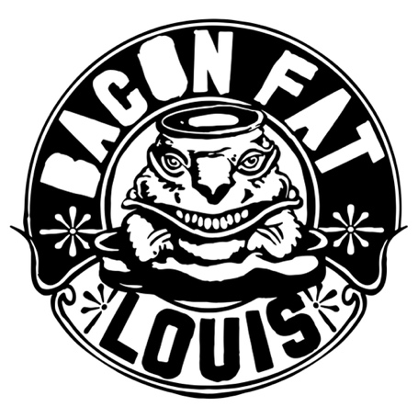

When you go to the pawn shop to buy the most shitty blender they have and you put in some RL Burnside, a slice of the Legendary Shack Shakers, some parts of Bob Log’s helmet, a few pieces of T-model Ford and a little bit of of Left Lane Cruiser then start mixing this at full speed, you will finally reach your goal; a completely new refreshing cocktail named Bacon Fat Louis!
The band, existing for almost ten years, has now definitely found their own way!
No complicated bullshit just some hot steaming no-nonsense boogie with a little taste of that fine voodoo garage-sound and always keeping the Blues as the foundation.
As the year 2020 passed by, they released their third album named BFL#3. The album got a lot of positive feedback, and very soon the band got shows and festivals in their home country and abroad.
It’s just impossible to stand still if you visit a gig of these pretty guys.
Dancing will be guaranteed!

Bacon Fat Louis is and always will be:
Bo Hudson: Guitar, vocals and some weird make-up
Thomas: Bluesharp , nice guy and so much more
Rik : Drums, and always to serious 